Lab-16 (Numpy)

1. Convert the below list into numpy array then display the array

 Input: my_list = [1, 2, 3, 4, 5]

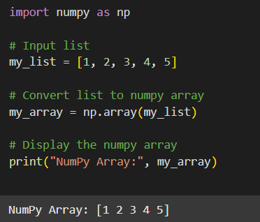

2. Convert the below list into a numpy array then display the array then display the first and last index and then multiply each element by 2 and display the result.

 Input: my_list = [1, 2, 3, 4, 5]

